**Distributed audio and video over IP system（MVWP3000）**

## Application Topology Map

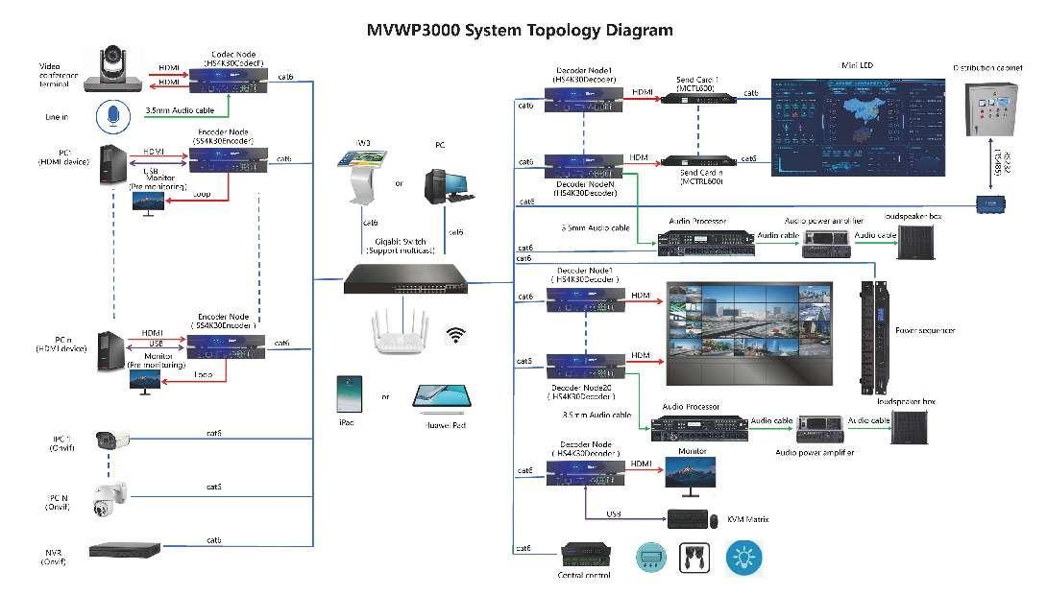

## Description of the main functions of the system

### HDMI matrix function:

supports matrix switching between multiple HDMI source inputs and multiple displays;

(1) One to many: synchronously displaying one of the signals from the source on the backend display screen

(2) Many to many: Display multiple signals from multiple sources on the corresponding large screen on the backend

(3) Mixed mode: Display two (one to many, many to many) mixed on the backend large screen

### Video Wall Function

(1) Support LCD large screen splicing, full screen display or partial splicing

(2) Supporting the adaptation of LED large screen splicing display with any resolution

(3) Support user-defined signal source resolution input based on LED large screen resolution

(4) Support decoding of multiple code streams per node, up to 64 D1 or 1 4K or 4 1080p channels, etc

(5) Support for arbitrary screen windowing, roaming, overlapping windows, splicing, etc

(6) Support precise synchronous display of LED and LCD large screen splicing, with synchronization accuracy up to 50us

### Decoding ability

(1) Single node decoding 1 channel 4K30 or 4 channels 1080p30 or 8 channels 720p30 or 16 channels D1

(2) Single screen tiled up to 64 views

(3) Support image window stacking with a maximum of 10 layers

### Audio matrix function

Support audio matrix switching between multiple audio sources (including digital and analog) inputs and multiple output nodes' audio outputs;

### KVM matrix function

Support remote control of multiple computers with one set of buttons and a mouse, as well as individual control of multiple computers with multiple sets of buttons and keyboards;

### Visualization operation

Support visual operations on operating terminals such as iPads, Pads, and IWBs.

(1) All signal sources are previewed on operating terminals such as iPad, Pad, and IWB;

(2) Real time synchronous display of display screens (splicing large screens) and operating terminals such as iPads, Pads, and IWBs;

(3) Support window operations such as zooming, moving, and dragging images with two or one finger;

### Transparent forwarding function of serial port:

Support RS232C, RS485 serial port Baud 4800, 9600, 115200, 384000, etc., support transparent forwarding mode

### Two power supply modes

Supports two power supply methods: DC12V1A adapter or POE.

## Introduction to Control Interface

### Windows、iPad，Pad Control Interface

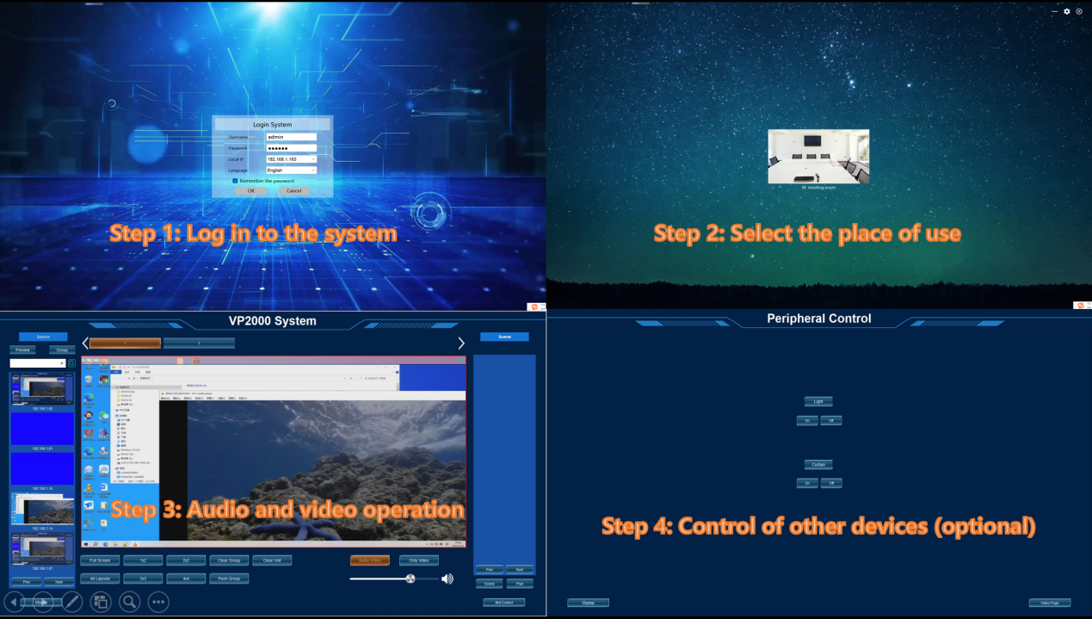

### System settings interface

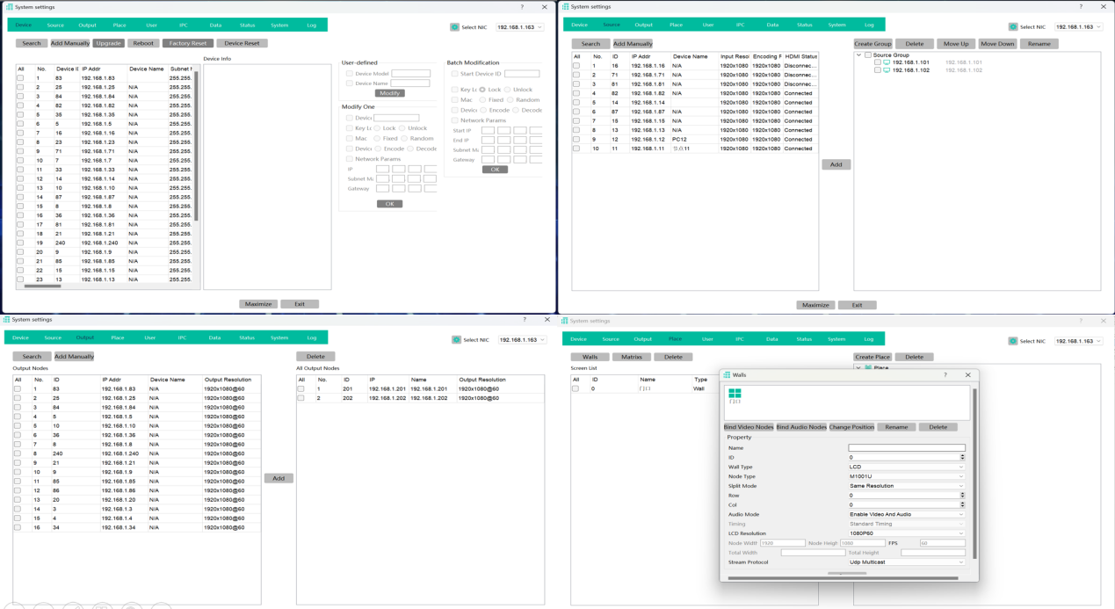

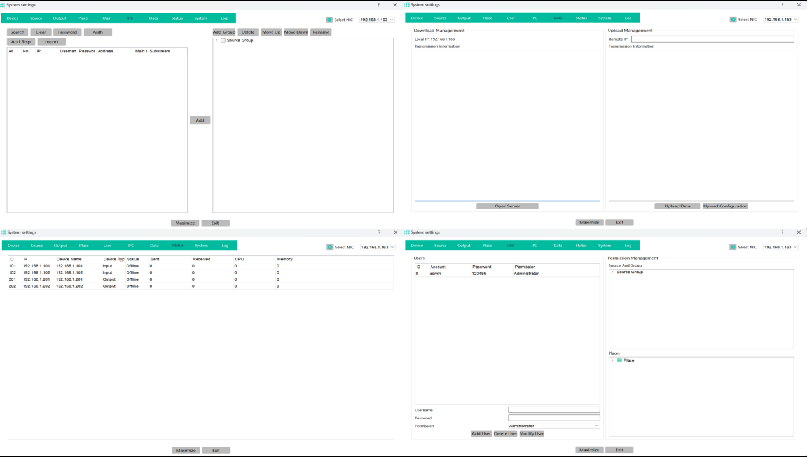

## Detailed product specifications

### HS4K30 Encoder/Decoder/Codec/KVM with HiSilicon Chipset

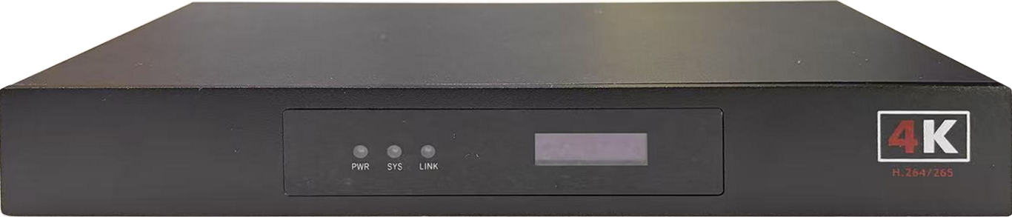 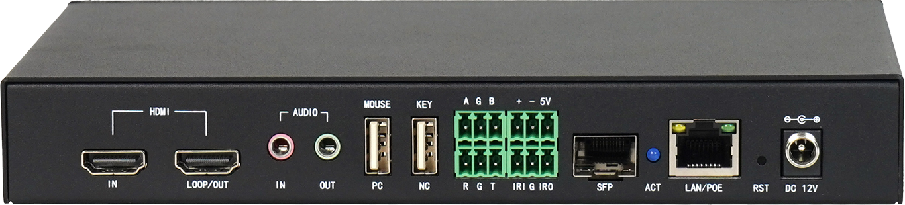

|  |  |  |  |  |  |
| --- | --- | --- | --- | --- | --- |
| **Model** | **HS4K30 Encoder/Decoder/Codec/KVM** | | | | |
| **Interface Name** | **interface type** | **Number** | | **Characteristic parameter** |
| **Video out** | **HDMI** | **1** | | **Max：3840x2160@30Hz** |
| **Audio interface** | **Audio in** | **HDMI** | **1** | | **Embedded digital audio input** |
| **3.5mm** | **1** | | **Analog audio input** |
| **Audio out** | **HDMI** | **1** | | **Embedded digital audio output** |
| **3.5mm** | **1** | | **Analog audio output** |
| **Network interface** | **Lan** | **RJ45** | **1** | | **10/100/1000 Base T** |
| **USB interface** | **USB** | **USB2.0** | **2** | | **Connect to computer** |
| **Control interface** | **RS232C** | **Phoenix terminal** | **3pin** | | **RS232C protocol bidirectional transparent transmission** |
| **RS485** | **Phoenix terminal** | **3pin** | | **RS485 protocol bidirectional transparent transmission** |
| **Relay**  **Control** | **Phoenix terminal** | **3pin** | | **Relay control output** |
| **IO input output** | **Phoenix terminal** | **3pin** | | **2-way IO input/output control** |
| **Electrical specifications** | **Power supply** | **DC12V** | **1** | | **With threaded locking device** |
| **POE(RJ45)** | **1** | | **POE power supply** |
| **Working hours** | **7x24x365** | | | |
| **Temperature** | **operation temperature** | | **0°C~60°C** | |
| **storage temperature** | | **-10°C~70°C** | |
| **humidity** | **Working humidity** | | **10%~90%，No condensation** | |
| **Storage Humidity** | | **10%~90%，No condensation** | |
| **MTBF** | **≤60000Hours** | | | |
| **Size（mm）** | **≈210mm×113mm×30mm** | | | |
| **weight（kg）** | **≈0.6KG(net weight）** | | | |

### HS4K60 Encoder/Decoder/Codec/KVM with HiSilicon Chipset

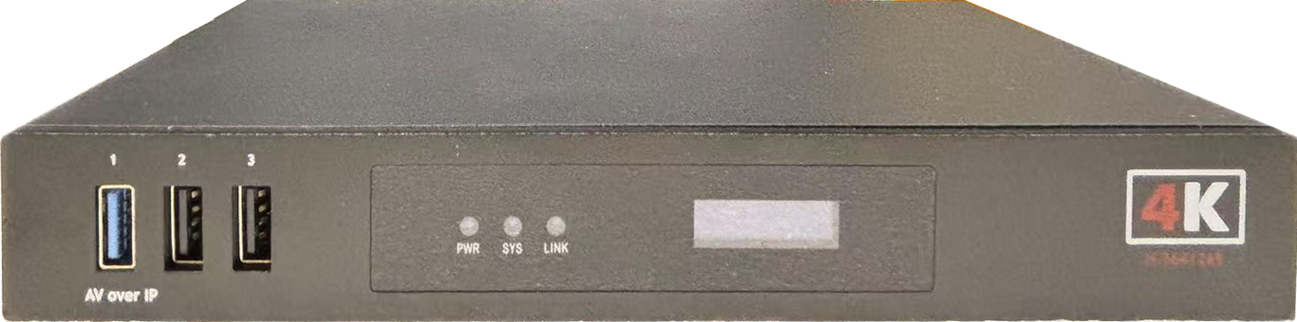 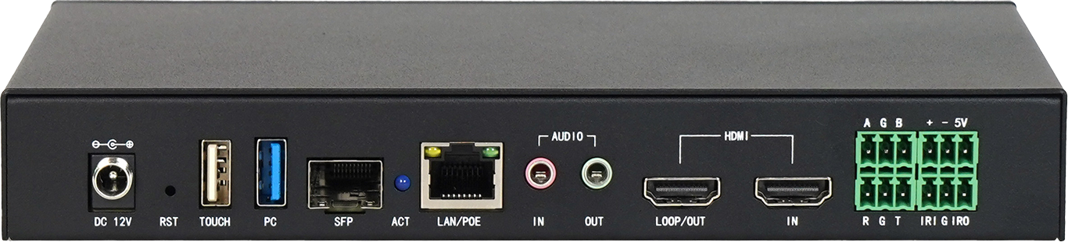

|  |  |  |  |  |  |
| --- | --- | --- | --- | --- | --- |
| **Model** | **HS4K60 Encoder/Decoder/Codec/KVM with HiSilicon Chipset** | | | | |
| **Interface Name** | **interface type** | **Number** | | **Characteristic parameter** |
| **Video interface** | **Video in** | **HDMI** | **1** | | **Max：3840x2160@60Hz** |
| **Video out** | **HDMI** | **1** | | **Max：3840x2160@60Hz** |
| **Audio interface** | **Audio in** | **HDMI** | **1** | | **Embedded digital audio input** |
| **3.5mm** | **1** | | **Analog audio input** |
| **Audio out** | **HDMI** | **1** | | **Embedded digital audio output** |
| **3.5mm** | **1** | | **Analog audio output** |
| **Network interface** | **Lan** | **RJ45** | **1** | | **10/100/1000 Base T** |
| **USB interface** | **USB** | **USB2.0** | **3** | | **Connect to computer** |
| **Control interface** | **RS232C** | **Phoenix terminal** | **3pin** | | **RS232C protocol bidirectional transparent transmission** |
| **RS485** | **Phoenix terminal** | **3pin** | | **RS485 protocol bidirectional transparent transmission** |
| **Relay**  **Control** | **Phoenix terminal** | **3pin** | | **Relay control output** |
| **IO input output** | **Phoenix terminal** | **3pin** | | **2-way IO input/output control** |
| **Electrical specifications** | **Power supply** | **DC12V** | **1** | | **With threaded locking device** |
| **POE(RJ45)** | **1** | | **POE power supply** |
| **Working hours** | **7x24x365** | | | |
| **Temperature** | **operation temperature** | | **0°C~60°C** | |
| **storage temperature** | | **-10°C~70°C** | |
| **humidity** | **Working humidity** | | **10%~90%，No condensation** | |
| **Storage Humidity** | | **10%~90%，No condensation** | |
| **MTBF** | **≤60000Hours** | | | |
| **Size（mm）** | **≈210mm×113mm×30mm** | | | |
| **weight（kg）** | **≈0.6KG(net weight）** | | | |

## Operation interface designer

### Support customizing the operation interface

### Support adding or deleting controls according to project requirements;

### Support the addition of third-party control protocols;

